KISI-KISI SOAL UAS PENGANTAR KONTROL

Inverse Laplace Transform

- Obtain the unit-step response of a unity-feedback system whose open-loop transfer function is
$$G\left(s\right)=\frac{4}{s(s+5)}$$

- Obtain the unit-impulse response and the unit-step response of a unity-feedback system whose open-loop transfer function is
$$G\left(s\right)=\frac{2s+1}{s^{2}}$$

- Figure 1 shows a position control system with velocity feecback. What is the response $c(t)$ to the unit-step input ?
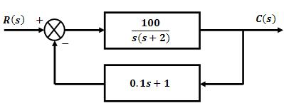
Figure 1

Second-order systems and transient-response specifications

- Consider the unit-step response of a unity-feedback control system whose open-loop transfer function is
$$G\left(s\right)=\frac{1}{s(s+1)}$$
Obtain the rise time, peak time, maximum overshoot and settling time

- Consider a unity-feedback control system whose open-loop transfer function is
$$G\left(s\right)=\frac{0.4s+1}{s(s+0.6)}$$
Obtain the response to a unit-step input. What is the rise-time for this system? What is the maximum overshoot ?

Proportional Control of Second-order system

- Consider the closed-loop system given by
$$\frac{C(s)}{R(s)}=\frac{{ω_{n}}^{2}}{s^{2}+2ζω_{n}s+{ω_{n}}^{2}}$$
Determine the value of $ζ$and $ω_{n}$ so that the system responds to a step input with approximately 5 % overshoot and with a settling time of 2 sec. (Use the 2% criterion)

- Referring to the system in Figure 2, determine the values of $K$ and $k$ such that the system has a damping ratio $ζ$ of 0.7 and an undamped natural frequency $ω_{n}$ of 4 rad/sec.
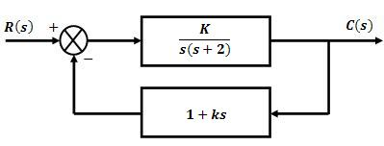
Figure 2

- Consider the system shown in Figure 3. Determine the value of $k$ such that the damping ratio $ζ$ is 0.5. Then obtain the rise time, peak time, maximum overshoot and settling time in the unit-step response.
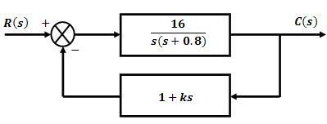
Figure 3

Routh’s Stability Criterion

- Apply Routh’s stability criterion to the following characteristic equation :
$$s^{4}+s^{3}+Ks^{2}+s+1=0$$
Determine the range of $K$ for stability

- Determine the range of $K$ for stability of a unity feedback control system whose open-loop transfer function is
$$G\left(s\right)=\frac{K}{s\left(s+1\right)(s+2)}$$

MATLAB Computation

- Consider the position control system shown if Figure 4. Write a MATLAB program to obtain a unit-step response.

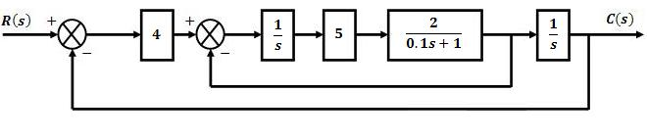
Figure 4

