Growth of Information technology.
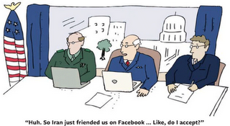
What you consider to be the most significant change in the nature of diplomacy?
The dynamics of diplomatic practice continues to evolve with globalisation setting current global trends, projecting the challenges faced globally. Any individual can be a diplomat, in different contexts. The end of the cold war saw a dramatic shift with the level of power the diplomatic office holds, technological advances creates challenges and obstacles for them. The International system has become more transparent, with media publications it has made it increasingly more difficult for any diplomatic talks to be held in private. Social networking sites and the vast information exchanges have interlinked communities from different parts of the world.
The internet makes us all an audience, UK foreign secretary David Miliband regularly blogs on current affairs website, (extract and link below). In the past diplomats answered to their heads of state etc, and civil society were verily kept in the loop. Also with 24 hours news coverage access available to us from all over the world, from CNN to Al-Jazeera, giving us more points of views.
Diplomats are experts in particular fields, with more knowledge and additional skill’s, they require more background information on other countries. Diplomacy is expanding, to fit the current situation culturally, economically and socially. The push for this I would say is the technologically advances more than anything another aspect, it has made us aware of what is going on worldwide, and governments need to keep civil society up to date on diplomatic efforts, its the trend to be more clear. Countries that are less transparent in their diplomatic relations, that do not have freedom of speech, and call for accountability are less favourable in the international arena.

