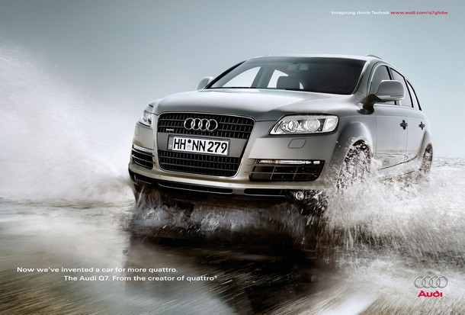

Task 1. Choose two advertisement for your essay.

Task 2. Write your essay about the design of the first advertisement.

Taks 3. Write your essay about the language of the second advertisement.

Goodluck and Thank You

