Development of E-Commerce Technology in World of Online Business
E S Soegoto^{1*,} A Christiani², and D Oktafiani³
¹Departemen Manajemen, Universitas Komputer Indonesia, Indonesia
²Departemen Teknik dan Ilmu Komputer, Universitas Komputer Indonesia, Indonesia
³Departemen Bahasa dan Sastra Inggris, Universitas Komputer Indonesia, Indonesia

*eddysoeryantos@email.unikom.ac.id

Abstract. The purpose of this research is to identify the development of e-commerce technology in the business world, and the benefits of the application of e-commerce in the online business. The method used in this research was the descriptive method, to present a complete overview of the situation related to some variable situations examined. The result of this research was to identify how far the development of e-commerce technology in the world of online business, as well as the benefits provided by the application of e-commerce in the world of online business. The research was done by discussing the payment transaction system, sales, and reservations made by the business by using e-commerce technology.

- Introduction
Gaikwad et all explains that the backbone of e-commerce marketing strategy is a recommender system that is a technique such as a memory-based collaborative filtering approach based on the similarity of users with rankings as attributes [1]. Likewise with Xie and Lui, who explained that the E-commerce system is identical with the reputation system, which is a system that gives scores to the seller about how much the seller can be trusted by the buyer [2]. According to Lu et all recommendation system is present to recommend a product to consumers or provide personalized online service to handle the problem of online information enhancement and improve customer relationship management [3].
Ahmed et all explains that the presence of e-commerce has created ease and innovation in human life. Variables such as perceived benefits, specific innovation domains, and shopping orientations, which are fast, branded and qualified indicate that online shopping interest is growing [4].
The research conducted by Rahayu and Day found that the factors that influence SMEs in developing countries in adopting e-commerce are technological factors, organizational factors, environmental factors and individual factors. However, for MSMEs in Indonesia, the decisive factor in adopting e-commerce is perceived benefits, technological readiness, own innovation, owner IT skills and IT owner experience [5]. Compared to studies conducted by Thananuraksakul on online buyers in Thailand found different results, research conducted Thananuraksakul found that the factors that affect the online buyer's intention are a positive attitude towards online shopping and trust [6]. Research conducted by Sharma and Lijuan against the factors that influence consumers to believe in e-commerce system and adopt e-commerce is the performance of e-commerce sites. That can facilitate the level of consumer confidence to shop to increase commitment and loyalty of consumers in buying an online product. So with the introduction of the internet and e-commerce, many companies choose to conduct business transactions through electronic networks, so this makes e-commerce network plays a vital role in online business [7].
Clemes et all explain more and more people around the world use the Internet as a global communication media, including in conducting online shopping. From the research conducted on the factors that influence the online consumer buying behavior in China found there are seven essential decision factors influence consumers in China to conduct online shopping activities, including perceived risk, consumer resources, service quality, subjective norms, variation product, convenience, and website factors [8]. Moreover, Hsu et all describe that to face the intense competition among online shopping sites, website managers must provide a safe and friendly shopping environment for users, thereby increasing consumer confidence by encouraging satisfied customers to provide positive support. [9].
Chang et all describe that the website must strengthen the quality and quantity of product information, and the website must provide a dynamic product presentation by presenting it in various forms such as multimedia and text descriptions of product-related information to increase consumer hedonic value. For security and privacy, the website must also provide customers with reliable safety features, such as a seamless communication channel in the form of dedicated phone services and email addresses and consumer privacy statements [10]. The purpose of this study is to identify the development of e-commerce technology in the world of online business, and the benefits of the application of e-commerce in the online business.

- Method

This research used the descriptive method to find out the related variables of e-commerce and online business, and use previous research related to the development of e-commerce and online marketing. So it can analyse how big the influence of e-commerce technology in the business world.

- Results and Discussion
To attract users to access the pages of the site in the online business world, the seller can upload and provide explanations of the products offered. For example, for an online business that offers beauty products, the products contained on the site various makeup options are ranging from the shop by brand, eyes, faces, tools. The payment method used by offering direct and indirect transactions. For example, an indirect transaction buyer ordered a payment product using ATM transfer transaction/cash deposit or Internet Banking while direct transaction user/buyer can directly come in the store.
Ordering can be made anytime, anywhere and anyhow following the wishes of the buyer, which can access via internet browsing on various electronic devices. Here Customer testimonial against online site shop Satisfied (quick response and goods also arrived fast, totally recommend) (Figure 1).

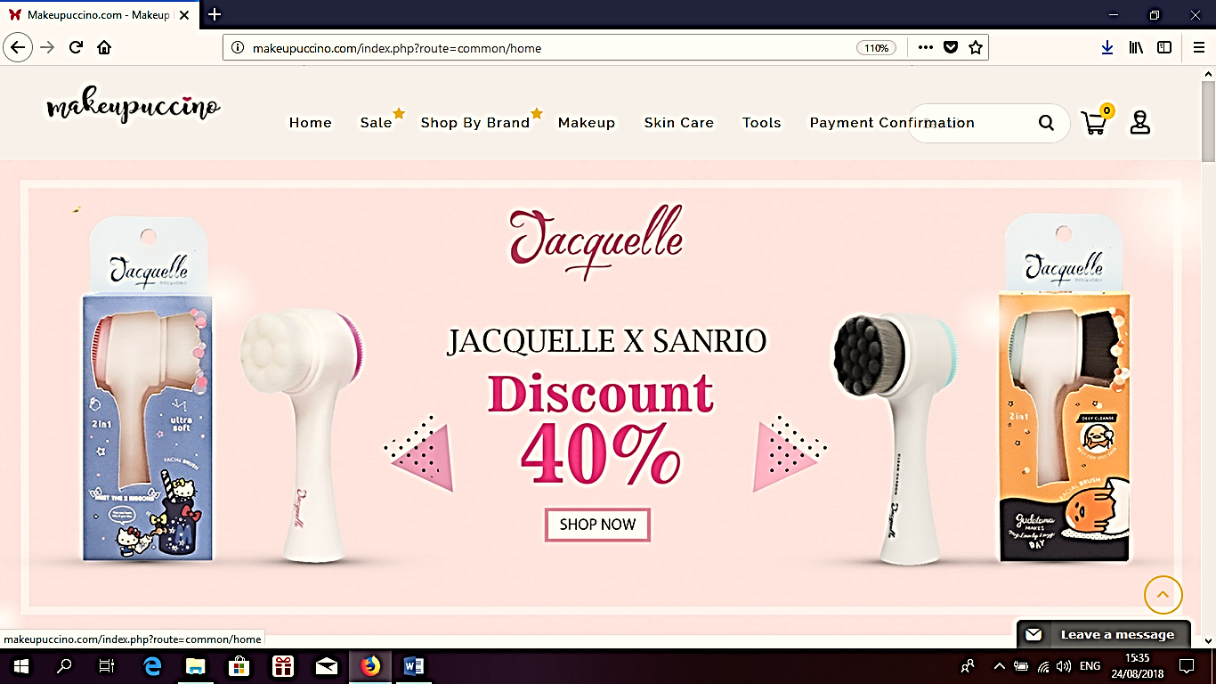
Figure 1. Main menu.
In the main view, there are sections like menus and submenus. So the seller and buyer can create and use the account as desired on the site. There are several products offered as well as the top products on this site page so users can quickly select the product. Sellers also have an advantage over using the main page because all the access users’ use is on the page. In this study, we develop information technology systems and product satisfaction of this online business (Figure 2).

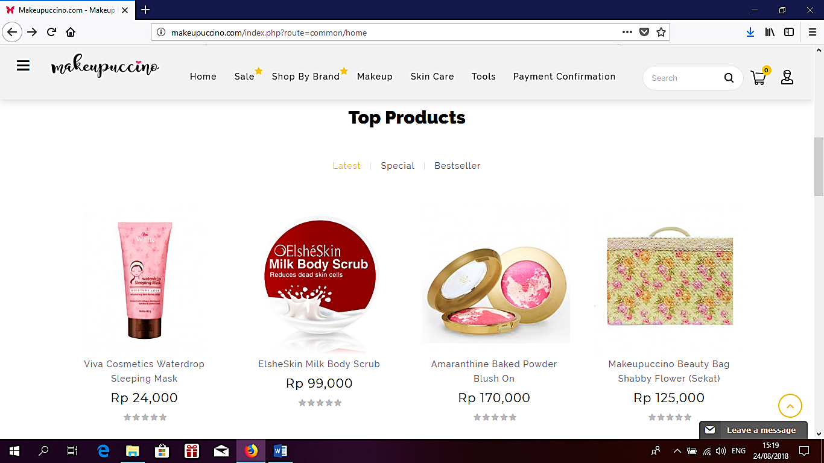

Figure2. Product Menu

In the product view, the user can select parts or select items to search. The products that are in Makeupuccino are local and overseas products, the products displayed are listed between price and product name completely. This view also lists the best seller to attract more buyers and then make transactions (Figure 3).
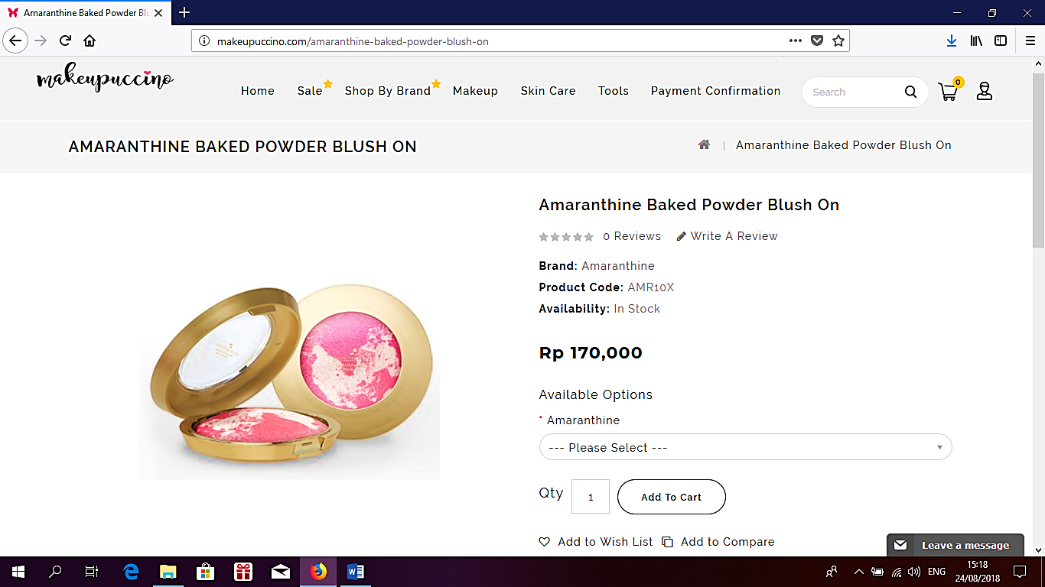
Figure 3. Product Recommendations Menu
After the user selects the desired item, the user selects the product to purchase. In this view, there is information about the description, brand, and price of goods notes about the product to inform the buyer about the type of goods or specification of the product so that the buyer knows the goods to be purchased (Figure 4).

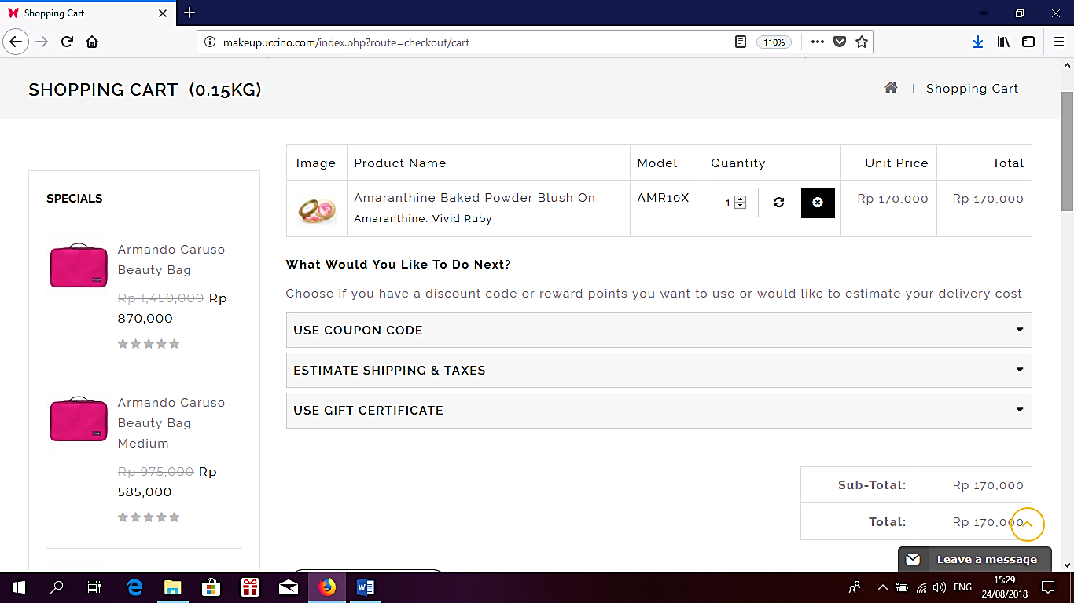
Figure 4. Purchase Form.

In the process of filling the data page of the buyer can check the items to be purchased and then the buyer fill out the correct address for delivery of the goods after the buyer select a shipping method available. Furthermore, choose the method of payment through Bank Transfer BCA / Mandiri after all data of the last complete confirmation of the order. The next step seller will send an email to the buyer for the account number to transfer or receive notifications via SMS if the buyer includes the phone number (Figure 5).

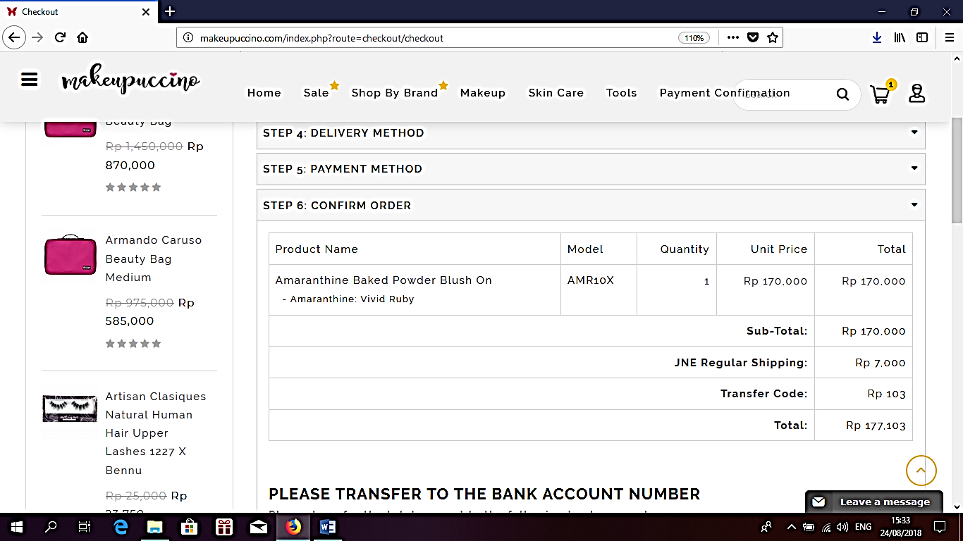

Figure 5. Form of Payment

Payment details on this online business have two choices of Transfer ATM and SMS / Internet Banking methods all processes that will be done in one way will be guaranteed security. If the buyer already makes the payment click payment and make sure all data is filled and correct, if in 2x24 hours the order is still not processed, please show of transfer to admin online business shop (Figure 6).

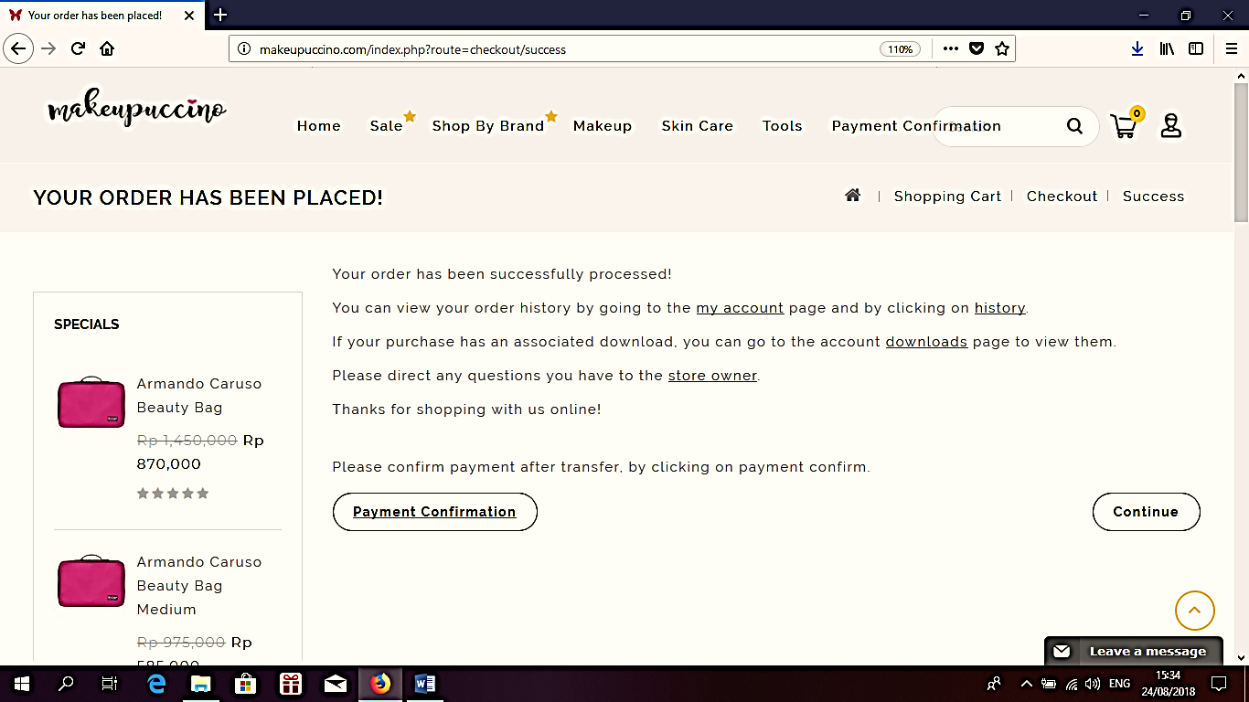

Figure 6. Payment Form.

After all data and payment have completed, then the buyer is just waiting for the goods delivered to the address according to the data that the buyer fill. The money transferred is non-refundable, and the products will arrive on time if the payment is correct. We also find an obstacle in the online shop Makeupuccino business in the process of sending so many buyers who feel dissatisfaction with the delivery service made in the process of buying and selling transactions on the online market.
- Conclusion
Technological developments provide convenience for people, especially in business and more comfortable for people to do shopping online and do not need to leave home only use mobile phones and the Internet can all be done quickly and efficiently. With e-commerce, consumers have comfort in transacting in the online purchase due to the seller obtained consumers may consider a ranking system regarding the quality of service of the online business sellers, and consumers are not worried in transfer payments.
References
[1] Gaikwad, R. S., Udmale, S. S., & Sambhe, V. K. 2018. E-commerce Recommendation System Using Improved Probabilistic Model. In Information and Communication Technology for Sustainable Development 8(6), pp. 277-284. Springer, Singapore.
[2] Xie, H., Ma, R. T., & Lui, J. 2018. Enhancing Reputation via Price Discounts in E-Commerce Systems: A Data-Driven Approach. ACM Transactions on Knowledge Discovery from Data (TKDD), 12(3), pp. 26 - 30.
[3] Lu, J., Wu, D., Mao, M., Wang, W., & Zhang, G. 2015. Recommender system application developments: a survey.Decision Support Systems, International Journals Sciences. 74(6), pp. 12-32.
[4] Ahmed, Z., Su, L., Rafique, K., Khan, S. Z., &Jamil, S. 2017. A study on the factors affecting consumer buying behavior towards online shopping in Pakistan. Journal of Asian Business Strategy, 7(2), pp. 44 - 50.
[5] Rahayu, R., & Day, J. 2015. Determinant factors of e-commerce adoption by SMEs in developing country: evidence from Indonesia. Procedia-Social and Behavioral Sciences, 195(6), pp.142-150.
[6] Thananuraksakul, S. 2018. Factors influencing online shopping behavior intention: A study of Thai consumers. AU Journal of Management, 5(1), pp. 41-46.
[7] Sharma, G., &Lijuan, W. 2014. Ethical perspectives on e-commerce: an empirical investigation. Internet Research, 24(4), 414-435.
[8] Clemes, M. D., Gan, C., & Zhang, J. 2014. An empirical analysis of online shopping adoption in Beijing, China. Journal of Retailing and Consumer Services, 21(3), pp.364-375.
[9] Hsu, M. H., Chuang, L. W., & Hsu, C. S. 2014. Understanding online shopping intention: the roles of four types of trust and their antecedents. Internet Research, 24(3), pp.332-352.
[10] Gaikwad, R. S., Udmale, S. S., &Sambhe, V. K. 2018. E-commerce Recommendation System Using Improved Probabilistic Model. In Information and Communication Technology for Sustainable Development 9(4) pp. 277-284. Springer, Singapore.

