DEFENSE MECHANISMS USED BY BOROMIR IN LORD OF THE RINGS: FELLOWSHIP OF THE RING
Sukma Eka Satya Ginalih
Kundae48@gmail.com
English Literature, Universitas Komputer Indonesia, West Java, Indonesia

…..(2nd Author)….

Abstract: The objective of this research is to analyze the defense mechanism used by Boromir. Also, the characterization are identified to conduct the research. This research applies several theory and method to analyze the data. Theories used are, characterization, psychoanalysis, and defense mechanisms. In the matter of defense mechanism, there are many types of it. So in this analysis, it is also aims to examine the types of defense mechanism used by the character.
Data are collected from scenes of the film, dialogues, gestures, responses and facial expressions of the character. The field of the study are around the scene of the films of which the character appeared. Some limited history are also studied, collected from the film and biography from other sources. The result of the research shows that the character uses several defense mechanism. The characterization of the character are also discovered. These characterization are obtained through the course of the analysis of the field of studies mentioned above.
Keywords: characterization, psychoanalysis, defense mechanism, film, biography.

INTRODUCTION
Lord of The Rings is an epic fantasy novel written by J.R.R. Tolkien. As the sequel to the first novel, The Hobbits, Lord of The Rings tells about the journey of Frodo Baggins which is Bilbo’s nephew to vanquish Sauron’s ring. Because of the big success on the trilogy, adaptations into movies are produced.
There are several Lord of The Rings adaptation movie, such as the cartoon version and a trilogy directed by Peter Jackson who also directed the extended version. The most famous trilogy directed by Peter Jackson is the regular version (Not extended version) which later become one of the base piece of work to make interest for the audience to seek more deeply about the stories and universe. As a novel adaptation, there are missing parts from the novel, but some parts are well interpreted into the screen casts and acting.
The first part of the trilogy which is The Fellowship of The Rings, is an introductory to the universe, races, and conflicts. Concerning about race, there are many races that played each important roles. Although hobbits as the main character, specifically Frodo, the most relatable for the audience is the human race. In this part, human races are not presented in many number. The only human that presents through the film is only Aragorn and Boromir. Both Tolkien and Jackson surprisingly brought out every races personality into every fellowship members especially Boromir and Aragorn. They are the part of the fellowship with each different traits. In the movie, Aragorn which was played by Viggo Mortensen portraits a man of focus and leadership towards the fellowship. Besides that, Aragorn is technically considered as the good guy in the movie but for Boromir it is different. Boromir could be considered as the part of character who made up a conflict in the narration. His desire for the ring, took over all of his control, even though his intention to use the ring was to save his people from destruction of the war. This shows an issue that makes him even more interesting than Aragorn. The issue that presented significantly by Boromir are his ego which is one of the traits that sometimes a man can have in real life. His egos are complicated throughout the film that led into a conflict. His egos are the main reason to conduct this research because he tried to fulfill his ego by maintaining his defense mechanism anytime possible.
There are several theories used in the analysis which is characterization, defense mechanism, and psychoanalysis itself.
Mieke Bal, in her book Narration: Introduction to The Theory of Narrative state that ‘character’ in a piece of literature is a common denominator to a person. Moreover, literature made around people and about people. Her statement are critics to other criticism which declares that character cannot be considered as a person or human being. But, Bal also declare that a character resembles some human traits such as psychological and ideological account. With this approach, character could be identified as a person in psychological and ideological matter. Aside from that, the characterization could be achieved with this approach (Bal, 1999).
Therefore, as the characterization has been identified the character could be analyzed furthermore with psychoanalysis approach. This analysis could be conducted because a character are considered as a person whereas a psychoanalysis is a therapy for a person who has a problem in their psychic.
Psychoanalysis is a studies of psychology around conscious and unconscious mind. Freud state that there are three form of human psychic which is Id, Ego, and Superego. The Id is the part of unconscious mind and act as the source of psychic energy. The Ego positioned between conscious and unconscious between unconscious and conscious mind that acts as mediator to attune demands and prohibitions. This ego however could be controlled by defense mechanism which could be worked unconsciously when there are too many anxiety and the mechanism hides it (Snowden, 2006). The Superego takes part both in conscious and unconscious mind and takes function as restrictor for the id action that would be taken by a person mostly to make awareness of good and bad values. This psychoanalysis aims to interpret the data to do the study and analysis to prove that there are similarities between Boromir and a person which leads into conclusion that Boromir is the representation of human nature.
The defense mechanism, which controls the ego, has the function to maintain emotional equilibrium of one’s mind (Bowins, 2004). Without defense mechanism, conscious mind would be most likely to be uncontrolled when the negative impulses from the id emitted. When this happened a person will have a feeling of anxiety, bad temper, and emotionally sad. This defense mechanism has many types in its implementation. Defense mechanism are also a method to keep out thoughts we don’t want to find or mixed up with reality that affects our action and behavior (Burgo, 2012). This method are analyzed by psychiatrist to recognize their patient’s problems or ‘illness’ of the mind. Same as this research, the analysis of the character are also recognizing the objects through the action in the film in order to discover the defense mechanism.
METHOD
The data are collected from scenes of the film. Considering the research subject is a film, in order to collect the data, the movie had to be paused every scene that considered as data. The selection of the scene are based on the dialogue, gesture, event, and facial expression. These selection base are important in order to conduct the research. One thing to note that the film is an adaptation from a novel.
First, the data are studied and also the character’s personality through attitude and response on some events such as action taken by the character, gestures, and facial expression. Then, after the subject are studied and the data collected, the data will be transferred into the research paper to do more study and analysis. All of data provided are purely taken from the character’s action, dialogue, and history. The author of the book and the produced has no connection with the character except the actor. The analysis uses several theorist and critics as the tools to do the analysis hoping the results will discover more knowledge and understanding to make the research even more logical and make sense.
FINDING AND DISCUSSION
Boromir
Boromir is one of the fellowship member as a volunteer from human race beside hobbits, elf, and dwarf to go into the quest to destroy the ring. In his first appearance, Boromir seemingly to be arrogant especially in the council, where he tries to take the ring. He proudly believe that he would make great deed out of the ring. While it seems to be noble act, it is also a selfish act to take considering there are consequences that would harm the others. He only cares about his nation despite his alliance with other races. But despite his arrogance and greed, there are also good side of him. His alliance with other races especially the enemy of Sauron,
In this research, there are several defense mechanism used by Boromir in attempt to fulfill his urge and ego as the results of his natural id.
Council of Rivendell
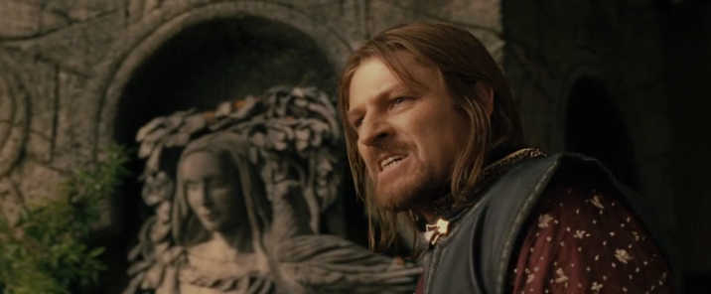
Pic 1. Council of Rivendell scene. Boromir’s arrogance
In the council of Rivendell, his defense mechanism work to fulfill his ego to protect his own land. The type that are used in this scene are denial. He ignore the fact that the ring is dangerous when anyone uses the ring, but Boromir ignores that to get what he needs. His characterization are also identified when he found the ring. He believe that the ring should be used for the resistance to fight back Sauron’s forces. While everyone disagree, he still stubbornly believe it should be used by the alliance although it was a wrong choice that will bring everyone into destruction. He still believe that no one could make the best deed of the ring, he still arrogant. To this part, his personality and act are still against everyone’s will to destroy the ring rather than use it. This could be seen when Elrond said it must be destroyed and then Boromir’s face expression shows disagreement and disappointment. Although his suggestions are denied, he still agree to company the fellowship through the journey. His arrogance again shows that his Ego are still disrespectful.
Anduin River
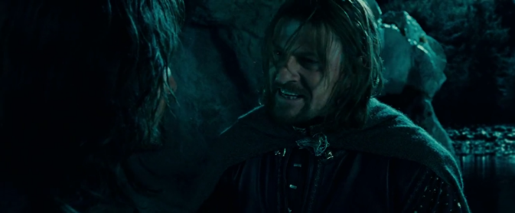
Pic 2. Anduin River scene. Boromir tries to convince Aragorn to change the course of the journey to Gondor.
“Have you so little faith in your own people? Yes, there is weakness. There is frailty. But there is courage also, and honor to be found in men”
In this scene, His ego are still on the urge to use the ring. The defense mechanism he used are still the same as before which is denial. He still ignores the danger of the ring. The characterization, Boromir’s pride as men are so great that he still chose the way to trust human race but without worrying about the other. Although Aragorn consider it as a reason to take over the ring, but Boromir insisted that no one believe human as an allies. This is because in the past, Isildur as a human betrays Elrond to destroy the ring while they had a chance to destroy it at once. Thus the human race are considered or seen as greedy creature. Same as Boromir, he planned to take the ring when the fellowship reached Gondor and that is another reason why Boromir could be depicted as true human nature, where greed and desire could be done in every way, good or bad. In this scene, his former Id emerges again. Though this time he might realize that is wrong decision which means his Superego are defeated to the id impulse resulting his Ego to take the treacherous acts. Therefore, his defense mechanism still uses denial.
Forest of Nen Hithoel
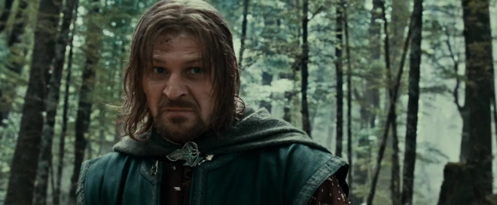
Pic 3. Forest of Nen Hithoel scene. Boromir cannot control himself, and betrayed Frodo.
“You fool! It is not yours save by unhappy chance...it might have been mine. It should be mine. Give it to me! Give me the ring.”
At the final stop, Boromir again showing his love and loyalty for his people which is Gondor. Strength means the power of the ring, he still believe the only way is to use the ring to fight Sauron. Before this scene breaks, he asked Frodo to give up the ring. Again, in that scene Boromir was still denial. Then, his defense mechanism breaks out into an anger. The type of the defense mechanism in this scene are displacement. He diplaces his desire to own the ring into? aggression to Frodo which is the ring bearer.
His desire are so great that he angrily declare that the ring should be for himself. In this moment, he’s out of control and totally consumed by his desire. It is whether because of the temptation made by the ring or his consciousness that his people are in peril and weighted to him for the responsibility and drive him mad. But one thing that could be noted: his loyalty for his people are undoubtedly great. Again his psychic are messed but this time his ego are really turned into outburst of anger which could be harmful for Frodo.
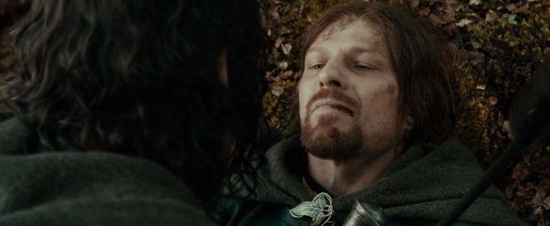
Pic 4. Forest of Nen Hithoel scene. Boromir’s death.
After the horrible thing that he done to Frodo, he finally awake and regret his choice. He tried to save Merry and Pippin from the orcs, but then he was overwhelmed by the horde. He died at the hand of the Uruk-hai. While struggling in his last breath, he finally redeem himself and salvation is at hand. He deeply regreted every action that he took. And he confessed that he was wrong to try to take the ring from Frodo, he could not control himself while he had a chance, he could not let go of Frodo.
In this last part, audience will feel a deep sympathy for him, he wanted to save his people from extinction. Although it is indeed a wrong way to make use of the ring, his heart are still noble. His madness could be caused by heavy burden of his people that he carries alone which leads him into greed and evil desire. In this scene, he was fully awoken. He lowered his Id and Ego resulting deep regrets and he redeem himself as the final Ego that he take.
***
As mentioned before, Boromir is the representative of true human nature in real life. His complicated personality depicts of how human could be so greedy for a power yet there are still humanity among bad sides. To prove this, analyzing the characterization of Boromir will do the proof. As Bal said a character could be a resemblance of a person although some theorist considered a character in narration is not real because they are just made up from imagination of the author. To make it clear, Bal declares that it is indeed not a real person but it resembles one which is psychological and ideological that made the characterization of the character (Bal, Introduction to the theory of narration: 115). For some audience it may hard to divide between story character and a person. For example, Boromir’s death could make the audience feel sympathy or indifference. In some parts especially in his first appearance, the audience maybe could take a conclusion that Boromir is a bad guy, but as the course of the story he could also considered as a good guy. These conclusion depends on the reader’s response or more precisely audience response towards him. Audience will get or feel same response similar to a real person despite the fact that Boromir is fictional or a story character. That is also the example that a character has psychological aspect that affects the audience too.
As for ideological aspect, Boromir only cares about his people and he believe that the ring would help him to restore their people’s strength and legacy. That is an example although a story character are considered not a real person, but it carries some aspect that could convince audience that they are also person but not a person. While it seems to be a contradictive statement, to make it clear, a person of story character are not fully considered as a person in real life. Moreover, we, as the audience of the film, has the common knowledge that the characters in the movie are fictional. In other hand, we also share sympathy and feeling between the character and audiences. As for that, some audience could sense a relatable feeling because Boromir is also human. This relatable feeling are because some are indeed could be considered as a stereotypical person (but not all) only if they are realize it enough as a human being. In conclusion for this, Boromir shares common personality as a real person which could be considered as a representative of human’s nature.
As for Foster’s, according to Bal, there are two types of characters. First is round and second is flat character. Round character are the complex one where through the course of the story, they will changed but mostly on their way of thinking which affects their reflex and attitude. While round character will mostly has a surprising element in some parts of the story, flat characters are the most straight and stereotypical one (Bal, Introduction to the theory of narration: 117). Their acts and thinking could be easily predicted which means they have no surprising elements. As for Boromir, in his first appearance could be seen as an arrogant person but later on he has the surprise element. In later part, his arrogance are concealed or even replaced by his care for others. For example in the exit of the Moria Mines, he let the other to rest for a moment and a moment to grieve for their loss of Gandalf. But then his bad sides keep appeared and also his good sides. By this matter, we could conclude that Boromir is actually a flat character. Because of his flat character we can also prove that the author or the director could brought out that Boromir is the depiction of a person. A human are a stereotypical concerning their personality, they could be corrupted by their desire for joy and pride but they also has the heart to do the good deed and cares for other.
CONCLUSION
As a result, the analysis discover that there are difference between analyzing text and a film. In analyzing film we could be helped by the visual presentation of every aspects which could not be shown in text. Although there are many parts that was missing and seemingly to be hasty especially in Fellowship of the ring, some major events are well presented. In analyzing character, beside textual or the spoken language, we could be helped by their gestures and face expression to obtain those character’s response towards things and events especially to reveal a character’s personality.
With separating the characterization of boromir and a person, we can conclude that he is indeed could be considered as a person despite the fact that he was a fictional character. He also could be seen as rather realistic character of how a person mostly to be specifically human being. Also, most of the aspects of Boromir in Fellowship of The Ring could trigger an audience response into some relatable feelings such as sympathy and indifference.
Also by revealing the characterization, its psychological could be identified. So it is proven that characters in almost any work could be considered as a ‘real’ character that has many traits that match human life. With this findings, it will be much of a help to conduct psychoanalysis as for this therapy are for a person or human. And finally, its defense mechanism could also identified.
In an answer to the research question, Boromir uses several types of defense mechanism through the course of the story. Those types are mainly denial and in the final scene he uses displacement, his anger are expressed to Frodo.
REFERENCES
Lord of The Rings: Fellowship of The Ring. Directed by Peter Jackson. Performances by Sean Bean, and Viggo Mortensen. 2002.
Bal, Mieke. (1997). Narration: Introduction To The Theory of Narrative. Second Edition. Toronto: University of Toronto Press.
Bowins, Brad. (2004). Psychological Defense Mechanism: A New Perspective. The American Journal of Psychoanalysis, Vol. 64, No. 1.
Mustikawati, Eka. (2014) Psychoanalysis in literature. Makassar: Hasannudin University.
Mario. Giovanny. A Psychoanalysis On The Main Character And The Author of Sherlock Holmes: A Study In Scarlet. Jakarta: Bina Nusantara University.
Eagleton. Terry. (1996). Literary Theory: An Introduction. Second Edition. Blackwell Publisher.
Burgo, J. (2012). Why Do I Do That? : Defense Mechanism. New Rise Press.
Boromir. Fandom Wikia. http://lotr.wikia.com/wiki/Boromir
Aragorn. Fandom Wikia. http://lotr.wikia.com/wiki/Aragorn_II_Elessar
Lord of The Rings: Fellowship of The Ring Movie Script. IMSDb. https://www.imsdb.com/scripts/Lord-of-the-Rings-Fellowship-of-the-Ring,-The.html
McLeod, Saul. (2017). Defense Mechanisms. Simply Psychology. https://www.simplypsychology.org/defense-mechanisms.html

