Algeria’s ‘lost generation’ has been shaped by years of conflict, unemployment and state repression. Sheep fighting offers an arena where young men can escape the constant supervision of the state. By Hannah Rae Armstrong
by Hannah Rae Armstrong
Published onFri 16 Feb 2018 06.00 GMT

Last August in Algiers, one week before the holiday of Eid al-Adha, men in tracksuits and trainers were guarding their sheep in anticipation of the fights to come. Kbabshis, as these men are known, scour villages looking for lambs that are fast, belligerent and shock-resistant. They then spend years raising them to be champion fighters. Coaches are tough but also surprisingly tender. They treat their sheep like mistresses, stopping by the garages where they install them, bringing food, caressing and massaging them before they head out together for long walks on the beach.
Professional trainers toughen their sheep by chaining their horns to a wall: as they pull and twist to break away, the resistance thickens their sinewy necks. Unlike with cockfighting, there is no gambling on sheep fights, but speculation on the sheep market can make it a lucrative trade. Each fight lifts the value of its victor and sentences the loser to slaughter. A champion ram might fetch as much as $10,000 – although most sheep trainers on a winning streak prefer to chase glory than cash. The sheep are given names that inspire fear, like Rambo, Jaws or Lawyer. In the third round of one recent match, Hitler delivered a brutal defeat to Saddam.

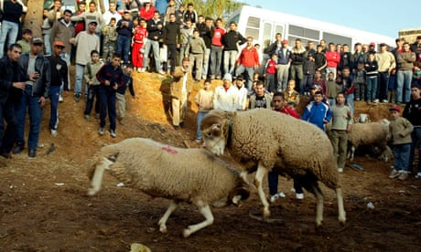
The brutal world of sheep fighting: the illegal sport beloved by Algeria’s 'lost generation' – podcast
Read more

Combat taa lkbech, which means sheep combat in the Algerian Arabic dialect, is a bit like football. It releases the pent-up energies of otherwise unoccupied men and allows them to safely act out potentially divisive strains of nationalism, regionalism and neighbourhood pride. But sheep fighting lacks the artistry, skill and precision that make football so enthralling: a sheep confronts an identical opponent and bludgeons him into submission using only his face. Matches are a festival of brute force and domination. When the sheep lose interest in a match, or prefer palling around with each other to smashing heads, the trainers take over, whispering and urging their beasts back into combat until they lock eyes once more and attack.
Advertisement
The men who train sheep for combat belong to a lost generation of Algerians, now in their 20s and 30s, moulded by an era of fear, fighting, corruption and curfews. There are few jobs and no productive roles for them to play in society. They lack relevant skills and education. Most are unmarried. They are not poor by most standards, but they depend on state subsidies that allow them to buy fuel, food and housing for next to nothing. They feel disposable, purposeless, humiliated. Most feel the future lies elsewhere. For many, that means Europe.
These young men have grown up in the shadows of two cataclysmic wars. Between 1954 and 1962, more than a million Algerian Muslims died during the war for independence from France. After almost 30 years of repressive one-party rule ended in 1991, Algeria descended into violence once again. For the next decade, a bloody conflict raged between security forces and Islamist insurgents, leaving some 200,000 Algerians dead. That period is commonly referred to as the “black decade”.

