METODA PERANCANGAN ARSITEKTUR II
PERTEMUAN KEDUABELAS + DARING + DUKUNGAN MULTIMEDIA + DISKUSI
SEMESTER GENAP 2019/ 2020
ANALISIS DAN SINTESIS DATA
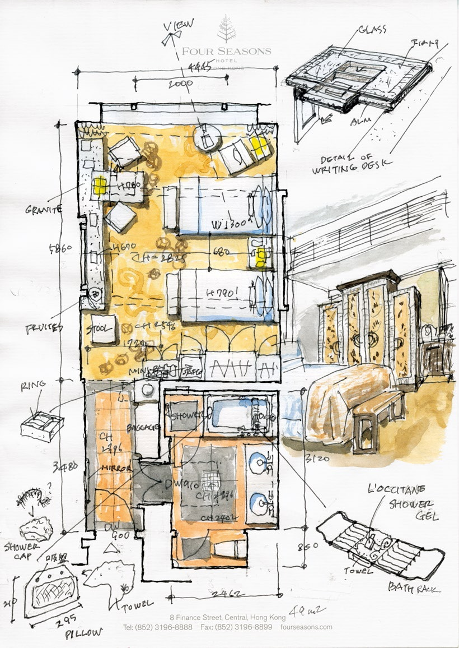Gambar di atas contoh Analisis sekaligus Sintesis
ANALISIS DAN SINTESIS DATA
2 ANALISIS UTAMA yang kita kenal, yaitu analisis terhadap 2 parameter perancangan yaitu TAPAK dan BANGUNAN. Analisis tersebut tentunya tidak dilakukan dengan kaku dilakukan satu persatu, dapat pula dilakukan secara bersamaan. Pada saat dilakukan analisis tapak dan sudah mendapatkan pemintakatan (zoning) dan dilakukan tata guna tapak, sudah dapat dilakukan analisis fungsi untuk sekaligus diterapkan di atas hasil analisis tapak tersebut sesuai dengan pemintakatan yang sesuai. Contoh: Ruang Penerima seperti Lobby, Receptionis, dan sejenisnya, dapat saudara letakkan di mintakat atau zona penerima pada tapak. Ruang–ruang service dapat saudara letakkan sesuai mintakat atau zona service pada tapak. Dan seterusnya.
ANALISIS – ANALISIS YANG DIPERLUKAN
TAPAK
The general categories of data we will be looking at as we carry out our architectural site analysis are:
- Location – where the site is situated
- Neighbourhood context – the immediate surrounding of the site including data on zoning and buildings and other impacts on our project.
- Zoning and size – dimensional considerations such as boundaries, easements, height restrictions, site area, access along with any further plans.
- Legal information – ownership, restrictions or covenants, council related information, future urban development plans.
- Natural physical features – actual features of the site such as trees, rocks, topography, rivers, ponds, drainage patterns.
- Man made features – existing buildings, walls, surrounding vernacular, setbacks, materials, landscaping, scale.
- Circulation – Vehicle and pedestrian movements in, through and around the site. Consider the timing of these movements, and duration of heavier patterns. Future traffic and road developments should also be considered.
- Utilities – Any electricity, gas, water, sewer and telephone services that are situated in or near the site, along with distances, depths and materials.
- Climate – all climatic information such as rainfall, snowfall, wind directions, temperatures, sun path, all considered during the different times of the year.
- Sensory – this addresses the visual, audible and tactile aspects of the site, such as views, noise, and so on. These again should be considered in time frames and a positive or negative factor can be attributed to the condition.
- Human and cultural – the cultural, psychological, behavioural and sociological aspects of the surrounding neighbourhood. Activities and patterns, density, population ethnic patterns, employment, income, values and so on.
https://www.firstinarchitecture.co.uk/architecture-site-analysis-guide-2/
Daftar di atas adalah daftar hal–hal yang dianilisis yang paling umum dilakukan, dapat berkurang atau bertambah sesuai dengan kebutuhan yang diperlukan oleh projek.

FIVE COMPONENTS OF ARCHITECTURE:
- Size and 2. Shape: What is the scale or relative size? • various squares, rectangles, circles, ellipses, curves, cubes, solids.
3. Location: How do you position the sizes and shapes? • placement, displacement, • edge (periphery) vs. center (core) • field (surface) vs. frame (edge) • in the ground/on the ground/above the ground • foreground/ middle-ground/ background relationship • figure/ground relationship • external/internal/interstitial.
4. Orientation: What is the viewer's approach to a size or shape? What is the directionality? • direction, redirection, reversals • exposure: north/south/east/west • horizontal/diagonal/vertical, • up/down, left/right, front/back • longitudinal/transverse • orthogonal/diagonal
5. Treatment: in what ways can you manipulate these sizes and shapes? • materials, pattern, texture, color • opacity, transparency, translucency, reflectivity • illumination, a"ects of natural and artificial light • light and dark relationships (contrast) • visual density, thickness or thinness • details and joints (articulation)
Hal penting lain yang berkaitan dengan analisis adalah
ANALISIS FUNGSI
- Analisis Fungsi, Fungsi Utama, Fungsi Sekunder, dan Fungsi Pendukung.
- Analisis Aktifitas: Identifikasi aktivitas individu, definisi aktivitas, penilaian atas kesamaan dan perbedaan aktivitas, klasifikasi berdasarkan kesamaan katagori fungsional, penilaian atas atribut-atribut aktivitas seperti jumlah orang atau pengguna, kondisi-kondisi yang diperlukan untuk kerja, jumlah, dan perioda waktu, identifikasi saling bergantung dan hubungan-hubungan lain, pengelompokan berdasarkan kesamaan dan kebergantungan, rekonsiliasi atas duplikasi dan konflik, organisasi menuju sistem baik eksisiting maupun yang diinginkan.
- Model-model Analisis Sosiofisikal
ANALISIS RUANG
- Standar-standar Unit Ruang
- Program Ruang
ANALISIS ENERJI
- Konservasi Enerji dan Desain Fasilitas
- Pertimbangan Enerji dalam Pemrograman
- Anggaran Enerji
ANALISIS BIAYA
- Perkiraan Estimasi Biaya
- Estimasi Biaya Konstruksi
- Evaluasi Biaya

TUGAS BESAR
Pilihlah suatu tapak dan fungsi sederhana, katakanlah fungsi penitipan sepeda, atau taman tempat istirahat, dan sebagainya. Analisislah tapak dan fungsi tersebut sedemikian rupa, pemintakatannya atau (zoning) antara tapak dan fungsi tepat.
SELAMAT BEKERJA SENDIRI ... BERDISKUSI DIPERKENANKAN ... COPY AND PASTE DILARANG!!!

