UJIAN AKHIR SEMESTER GENAP
TAHUN AJARAN 2012/2013

NAMA MATA KULIAH | : | BUSINESS CORRESPONDENCE
HARI/TANGGAL | : | SENIN, 1 JULI 2013
DOSEN | : | RETNO PURWANI SARI, S.S., M.HUM
WAKTU/KELAS/SKS | : | 90 MENIT/10AK-4/4 SKS
RUANG | : | 2402
SIFAT UJIAN | : | TAKE HOME TEST

- ORDERING SUPPLIES
Verb used with order The verbs in the box can all be used with the noun ‘order’.
Choose the best verb to complete each sentence. Use each verb only once, and in the correct form.

confirm | refuse | ship | despatch
place | make up | cancel | acknoledge

- We would like to ................................ an order with you for 5.000 units.
- As we are unable to supply the quantity you asked for, we would have no objection if you preferred to ..................................... your order.
- I am writing to ............................. your order, which we received this morning, for 20 ‘Omega Engines’.
- We are pleased to inform you that your order K451 has already been ........................ from our depot.
- Please .............................. in writing, so that we can inform our distribution depot.
- Your order was .............................. yesterday on the MV Oxford.
- Unfortunately, we shall have to ........................... your order unless payment is settled in cash.
- I would like to reassure you that your order will be .................................... in our depot by staff who has experience in handling these delicate materials.

- Placing an order: In this email Mr. Takahashi is placing an order, but the
accompanying email sentences have become confused. Rewrite the email with
the sentence in the correct order, starting new paragraphs
where appropriate.

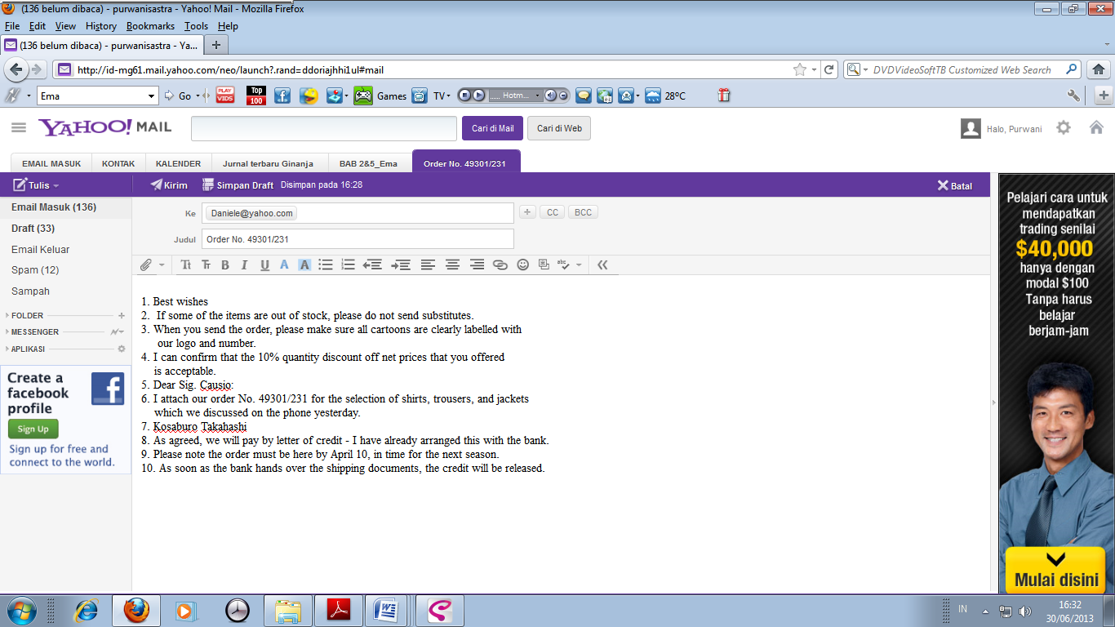

- Write a letter to confirm the orders listed in the following order logs. Look in your local telephone book or on the Internet for names and addresses to use in your letter.

Order logs No. 43901/241
Items | Ordered Stock | Number | Status Action
Shirts | S288 | 100 | In phone conversation yesterday, client agreed to divide 50 for white plain and 50 for blue striped; to be shipped overnight at client’s expense
Sweaters | S359 | 100 | In stock shipped overnight

