List of phrases to describe charts

The pie chart is about ...
The bar chart deals with ...
The line graph (clearly) shows ...
The slices of the pie chart compare the ...
The chart is divided into ... parts.
It highlights ...
... has the largest (number of) ...
... has the second largest (number of) ...
... is as big as ...
... is twice as big as ...
... is bigger than ...
more than ... per cent ...
only one third ...
less than half ...
The number ...
increases/goes up/grows
by ...
The number ...
decreases/goes down/sinks
by ...
The number ...
does not change/remains stable
I was really surprised/shocked by the ...
So we can say ...

Verbs | Nouns
Upward Movement
Rise (to) | a rise
Increase (to) | an increase
Go up to
Grow (to) | growth
Climb (to) | a climb
Boom | a boom
Peak (at) | (reach) a peak (at)
Downward Movement
Fall (to) | a fall (of)
Decline (to) | a decline (of)
Decrease (to) | a decrease (of)
Dip (to) | a dip (of)
Drop (to) | a drop (of)
Go down (to)
Reduce (to) | a reduction (of)
 | A slump
Stability
Level out/ level off | a leveling out
Flatten out
Hold steady
No change | no change
Remain stable (at)
Remain steady (at)
Stay (at)
Stay constant (at)
Maintain the same level
Adjectives | Adverbs
Dramatic | dramatically
Sharp | sharply
Huge | hugely
Enormous | enormously
Steep | steeply
Substantial | substantially
Considerable | considerably
Significant | significantly
Marked | markedly
Moderate | moderately
Slight | slightly
Small
Minimal | minimally
Describing the Speed of a Change
Adjectives | Adverbs
Rapid | rapidly
Quick | quickly
Swift | swiftly
Sudden | suddenly
Steady | steadily
Gradual | gradually
Slow | slowly

Example:
- From October to December, attendance decreased steadily.
- From October to December, there was a steady decrease in attendance.

Example:
Population growth in Canada
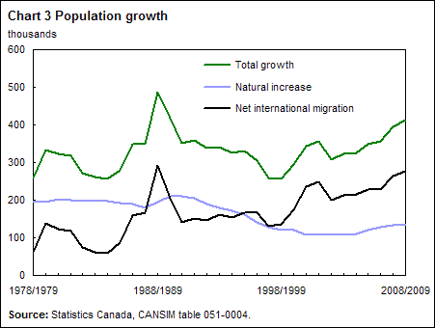

This graph shows the growth of the population in Canada from 1978 to 2009. It is taken from the website about Statistics in Canada.
There are three graphs in the chart. The green graph shows the total growth of the population, the black one deals with the migrated people in Canada and the blue graph shows the natural increase of the population. In 1988/89 there was an enourmous growth. In the following years the total growth went down to about 250,000 in 1998/99. From that time on the Canadian population has been gradually growing again although the natural increase slows down. So we can say that the growth of the population in Canada is based on migratio

