HOW TO DRAW DATA FLOW DIAGRAMS

What are Data Flow Diagrams?
Data flow diagrams illustrate how data is processed by a system in terms of inputs and outputs.
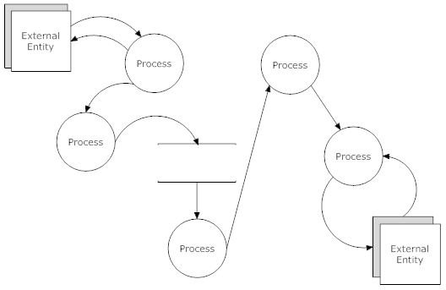
A data flow diagram

Data Flow Diagram Notations
You can use two different types of notations on your data flow diagrams: Yourdon & Coad or Gane & Sarson.

Process Notations
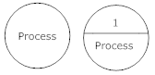
Yourdon and Coad
Process Notations
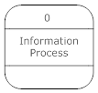
Gane and Sarson
Process Notation
Process
A process transforms incoming data flow into outgoing data flow.
Learn how to edit text on this object.

Datastore Notations
Yourdon and Coad
Datastore Notations
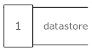
Gane and Sarson
Datastore Notations
DataStore
Datastores are repositories of data in the system. They are sometimes also referred to as files.
Learn how to edit text on this object.

Dataflow Notations
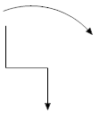
Dataflow
Dataflows are pipelines through which packets of information flow. Label the arrows with the name of the data that moves through it.
Learn how to connect objects.
External Entity Notations
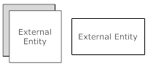
External Entity
External entities are objects outside the system, with which the system communicates. External entities are sources and destinations of the system's inputs and outputs.
Learn how to edit text on this object.
Data Flow Diagram Layers
Draw data flow diagrams in several nested layers. A single process node on a high level diagram can be expanded to show a more detailed data flow diagram. Draw the context diagram first, followed by various layers of data flow diagrams.
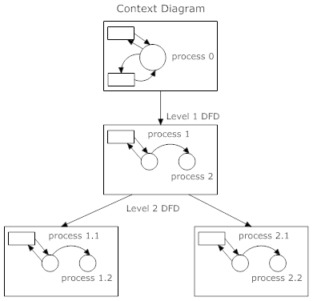
The nesting of data flow layers

Context Diagrams
A context diagram is a top level (also known as Level 0) data flow diagram. It only contains one process node (process 0) that generalizes the function of the entire system in relationship to external entities.
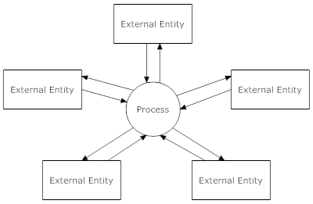
DFD levels
The first level DFD shows the main processes within the system. Each of these processes can be broken into further processes until you reach pseudocode.
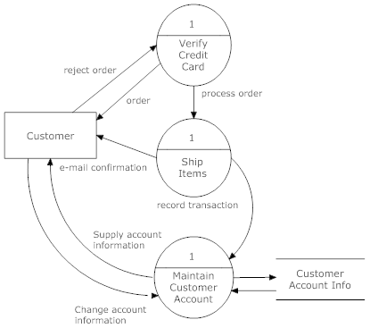
An example first-level data flow diagram

Drawing Nested DFDs in SmartDraw
You can easily nest data flow diagrams in SmartDraw. Draw the high-level diagrams first, then select the process you want to expand, go to the Tools menu, and select Insert Hyperlink. Link the selected process notation to another SmartDraw diagram or a web page.
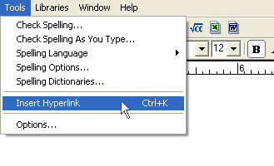

Once linked, a small plus sign will appear in the object, and clicking on it opens the linked file.

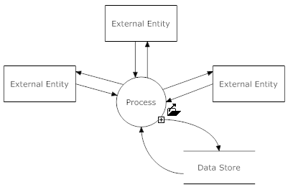
Clicking on the plus sign will open the linked file

When you link two SmartDraw files, the link created between them is absolute, not relative. (A link to a file on your hard drive will look something like this: C://SmartDraw Files/Project X/dataflow2.sdr instead of a relative link: dataflow2.sdr) In order to share your files with others, you can either save your files to a network drive or save and publish them as web pages. If you save your diagrams on a network, make sure you go to Network Neighborhood or My Network Places to find the appropriate directory instead of using your local mapped drives.
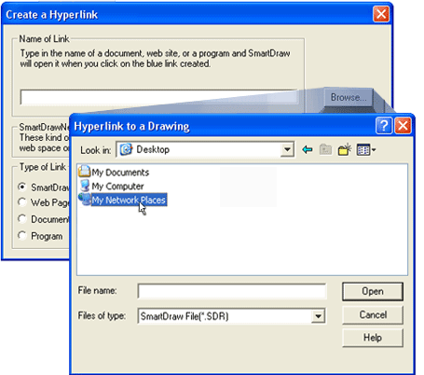
Browse on your network to find the files you want to link to

You can use this hyperlink function to open any kind of file, including text documents, spreadsheets, web pages, or even to launch a program!

