Tugas Praktikum no 1

import java.util.Scanner;
public class Praktikum1 {
public static void main (String [] arg)
{
String nama, nim;
float nilai;
// membuat scanner baru
Scanner keyboard = new Scanner(System.in);
// Tampilkan output ke user
System.out.println("Program Mulai");
System.out.print("Nama mahasiswa: ");
// menggunakan scanner dan menyimpan apa yang diketik di variabel nama
nama = keyboard.nextLine();
// Tampilkan outpu lagi
System.out.print("NIM Mahasiswa: ");
// menggunakan scanner lagi
nim = keyboard.nextLine();
System.out.print("Nilai Mahasiswa: ");
nilai = keyboard.nextFloat();
if (nilai >= 80)
System.out.println("lulus: ");
else
System.out.println("tidak lulus");

System.out.println("Program Selesai");

}
}

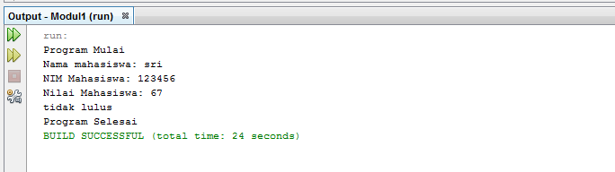

Tugas Praktikum no 2

public class Praktikum2
{
public static void main (String [] arg)
{
int i = 10;
int j;
System.out.println("Program Mulai");
for ( ; i>=1; )
//while (i >= 1)
{
System.out.print("Anak ayam turun " + i);
System.out.println();
j = i - 1;
System.out.println("Mati 1 tinggal " + j);
i--;
}

System.out.println("Program Selesai");
}
}
