CONSECUTIVE INTERPRETING

Materi
Mata Kuliah | : | Translation IV
Kelas yang diajar | : | 16SI-1
BUKTI PEMBELAJARAN DARING
Screenshot bukti upload materi di https://lms.unikom.ac.id atau https://kuliahonline.unikom.ac.id

Translation English-Indonesian IV

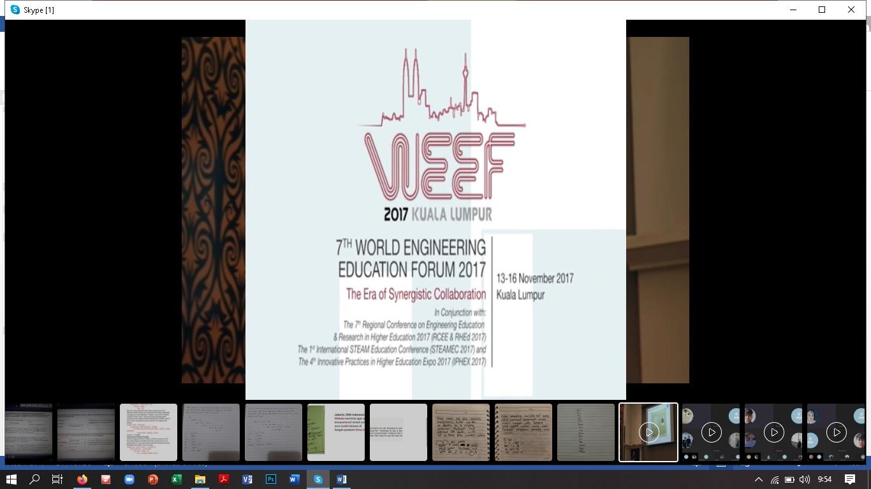

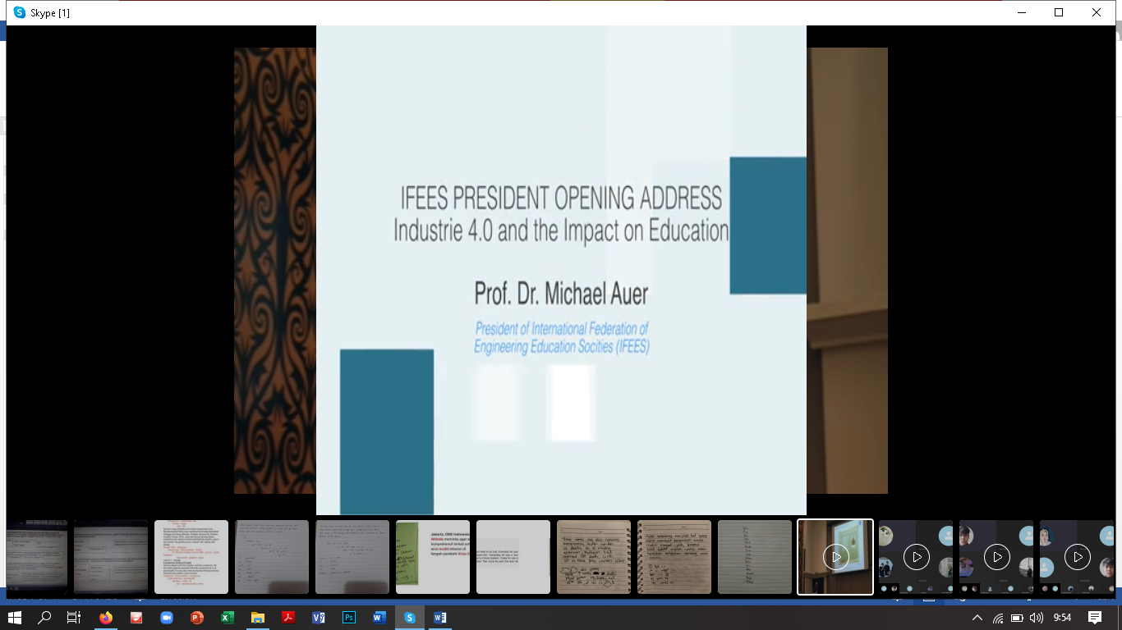

Translation Indonesian-English IV
